 

Welcome to First Day™!

Benefits of this program include:

* Discounted pricing on your required course materials (your price: only $68.50, compared to national price of $120.00 per term)
* Course materials are billed to your student account (works with financial aid too)
* Seamless digital access to your materials on or before the first day of class

You have already paid for your course materials through the registration process. The cost of digital course materials for this class will be included in your student bill and are guaranteed to be the lowest cost available to purchase your required materials. **NO other purchase is necessary.**

**The courseware (WileyPLUS) is required to complete the course.**

It is **NOT** recommended that you opt-out of the First Day program. You may choose to opt-out prior to 02/05/20 but you will then be responsible for purchasing your course materials at the full retail price and access to your materials may be suspended.

**Simply follow the directions and screen shots below to access your WileyPLUS courseware (course show below is sample, not actual course).**

**Login in to Canvas and select your course:**

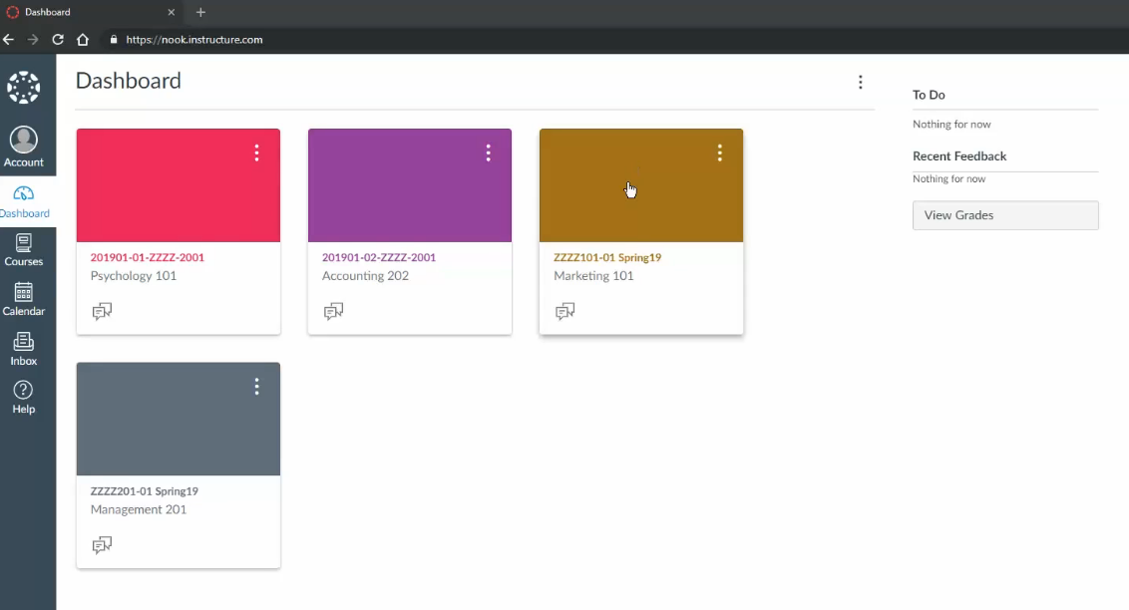

**2) You will be taken to our account set up screen. You will be able to log in using 1 of the 3 options below**

* **If you have used WileyPLUS in the past click Existing account to sign in**
* **If you would like to stay anonymous click “Stay anonymous”**
* **If you are new to WileyPLUS click “Create new account”, and complete below form and you will get an email with a 4-digit code to activate your account.**

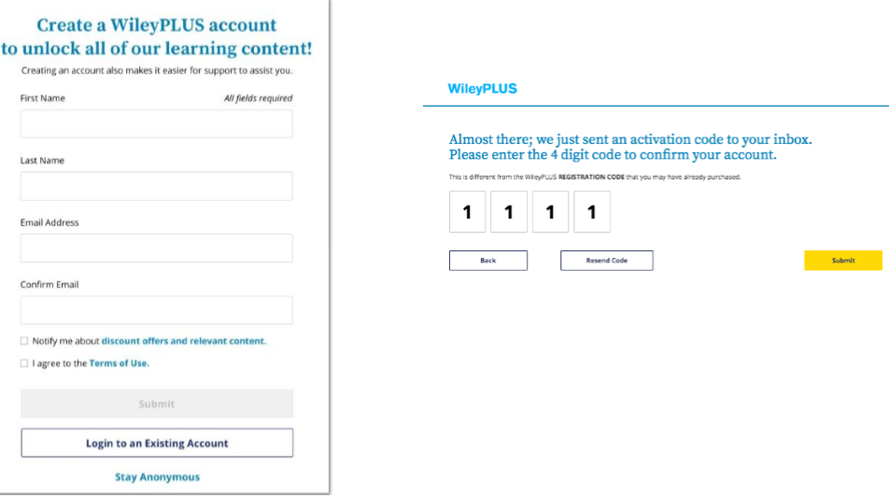

**NOTE: If you choose to Act Anonymous you will see a warning message. You may either cancel or click proceed**

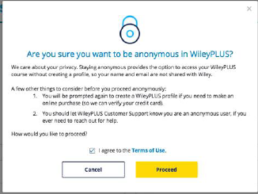

**3) Once registered, you will be taken directly into the WileyPLUS content (screen may look different depending upon course and the content link clicked)**

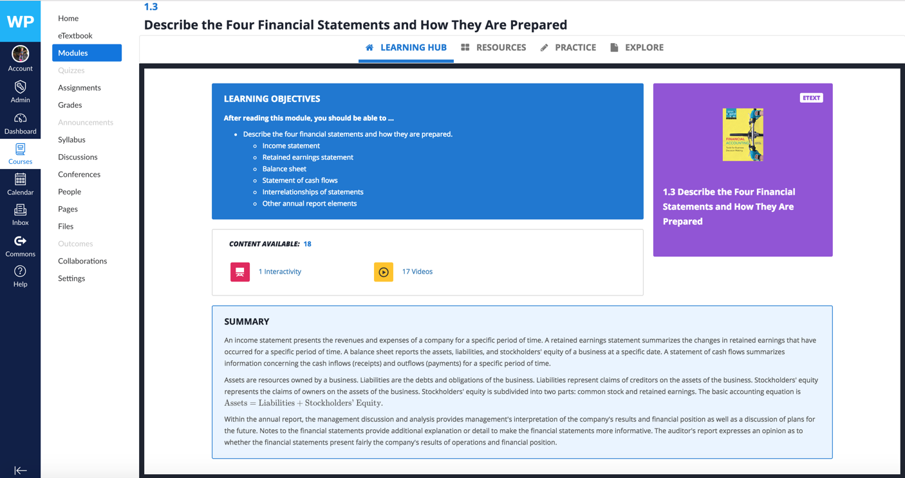

***\*\*\*If you OPT OUT of the First Day program, shortly after the deadline 02/05/20, your access to the WileyPLUS with the e-text, resources and homework will be terminated. At that point, you will need to purchase a code from the bookstore or directly in WileyPLUS:***

* When you click on any WileyPLUS content in Canvas, you will then be presented with the shopping cart where you can buy direct or enter a code purchased at the bookstore *(this sample screenshot below may not reflect pricing for your course).*

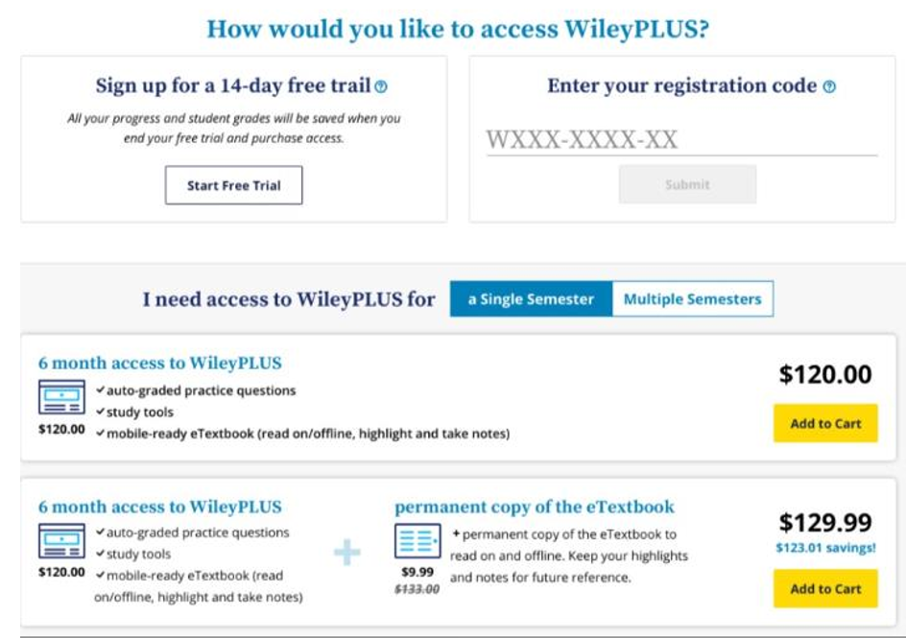

**NEED HELP?**

**For First Day Program questions**:

The Campus Bookstore also offers 24/7 Support via:  
**Web:** [customercare.bncollege.com](https://customercare.bncollege.com/hc/en-us)  
**Toll Free:** 1-844-9-EBOOKS (1-844-932-6657)  
**Email:** [bookstorecustomercare@bncollege.com](mailto:bookstorecustomercare@bncollege.com)

Your store manager is David Lang

[jlang@bncollege.com](mailto:jlang@bncollege.com)

(859) 257-0236

**Opting Out of First Day for your courseware**: <https://vimeo.com/304674959>

**For E-Text: 844-YUZU-NOW**

**Need Help with WileyPLUS?**

**WileyPLUS registration tips, Technical Support, Video Tutorials and FAQs:**

<http://wileyplus.wiley.com/student-resources-support/>

**LIVE CHAT!** Technical Support: **www.wileyplus.com/support**